Bansilal Ramnath Agarwal Charitable Trust’s
VISHWAKARMA INSTITUTE OF TECHNOLOGY – PUNE

CS2311: Software Engineering

Division |  |  | SY CS-A
Batch |  |  | 3
GR Number (PRN) |  |  | 12413610
Roll No. |  |  | 10
Name |  |  | ABHISHEK SARAF

Assignment 3

Problem Statement
- Create and manage use case diagrams for a real-world application (e.g., Online Shopping System) to capture functional requirements.

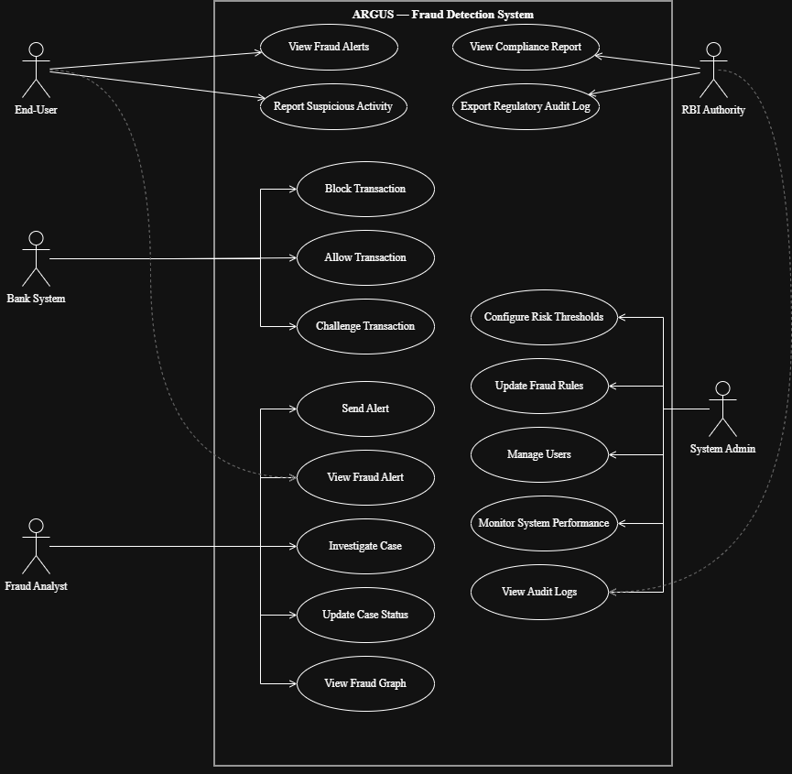

Use Case Diagram

